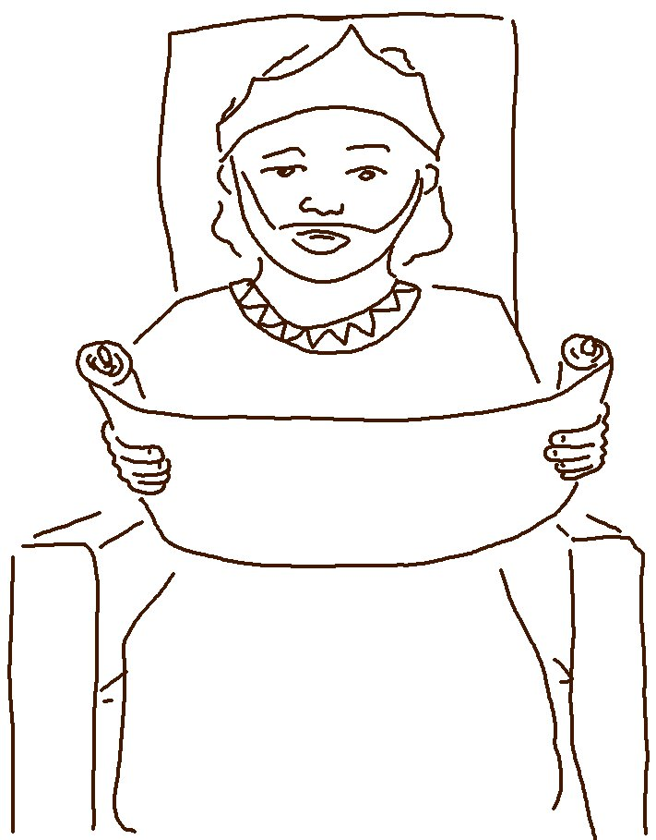

If you _ _ _ _ me, obey my _ _ _ _ _ _ _ _ _ _ _ _.
John 14:15_{NLT}

